Evolution unit study guide/test questions
There are 12 questions, including 8 different types of questions. You will answer 5 questions total and you must answer 5 different types of questions. Types of questions are Evaluating, Applying concepts, Predicting, Analyzing graphs, Formulating hypotheses, Using models, Making connections, Classifying
- (Evaluating)Decide if you agree or disagree with the following statement and write a paragraph with at least 3 pieces of supporting evidence for your position: Since civilized humans no longer live in natural environments, natural selection is no longer operating to shape human evolution
- (Applying concepts)Explain using at least 3 pieces of supporting evidence how natural selection might have produced the modern giraffe from short-necked giraffes
- (Predicting)Although wild turkeys can fly, domestic turkeys can’t. Suppose a population of domesticated turkeys escaped from a farm into a new environment. Give at least 3 examples of environmental conditions that might determine whether the population would survive over time
- (Analyzing/interpreting graphs) Look at the graph below and answer the following questions
  - What is the shortest and longest beak length observed in the graph on the left?
  - What percentage of the species of birds have these beak lengths?
  - What is the beak length that most individuals in the population have?
  - What is the shortest and longest beak length observed in the graph on the right?
  - What percentage of the species of birds have these beak lengths?
  - What is the beak length that most individuals in the population have?
  - Based on the data, what can you infer about the sizes of seeds eaten by each species and why?
  - What kind of selection is the graphic showing? Explain your answer.
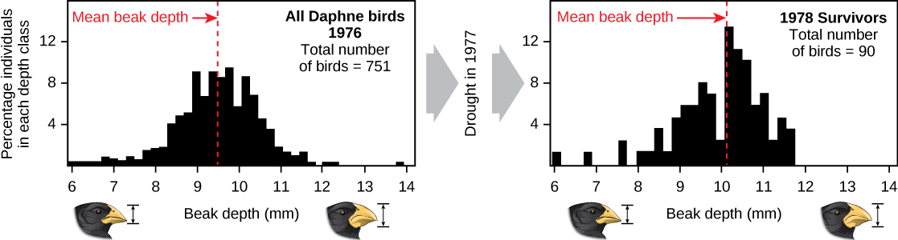

- (Formulating hypotheses) DDT is an insecticide that was first used in the 1940’s to kill mosquitos and stop the spread of malaria. At first it was very effective but over a period of years it became less effective. Explain what you think might have happened and how it might have happened. What is happening now that is similar to what happened with DDT?
- (Using models and applying concepts) Construct a model to simulate genetic drift due to a small population’s separating from a large population and establishing a new, distinct gene pool. Will evolution occur? Explain your answer using evidence and what you have learned in this unit. How might a gene pool with minimal genetic variation be dangerous for a particular species? Would that population evolve? Would it evolve the same or differently than the first population?
- (Applying) In what way might the cells that took in the ancestors of mitochondria and chloroplasts have benefited from the relationship?
- (Applying) Evolutionary biologists say that there is a good reason for gaps in the fossil record. Can you explain why some extinct animals and plants were never fossilized?
- (Making connections)When the Earth’s atmosphere first began to form, it did not contain oxygen, and hydrogen was the most abundant element in the solar system. However there is very little hydrogen in the atmosphere today, and hydrogen makes up less than 1 percent of the Earth’s mass. What might have happened to the hydrogen?
- (Applying concepts) The graph shows an approximation of the amount of oxygen in the atmosphere since life began. What events occurred at the points indicated by the arrows? Explain your answer (give evidence)
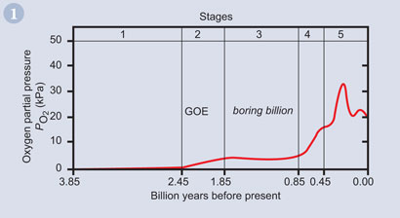
- (Classifying) A Venn diagram is shown below. Each region (A,B,C,D) represents a collection of organisms of a taxonomic level (e.g. family or species). Use the following terms to label the regions in the diagram: All animals, animals that have backbones, insects, mammals
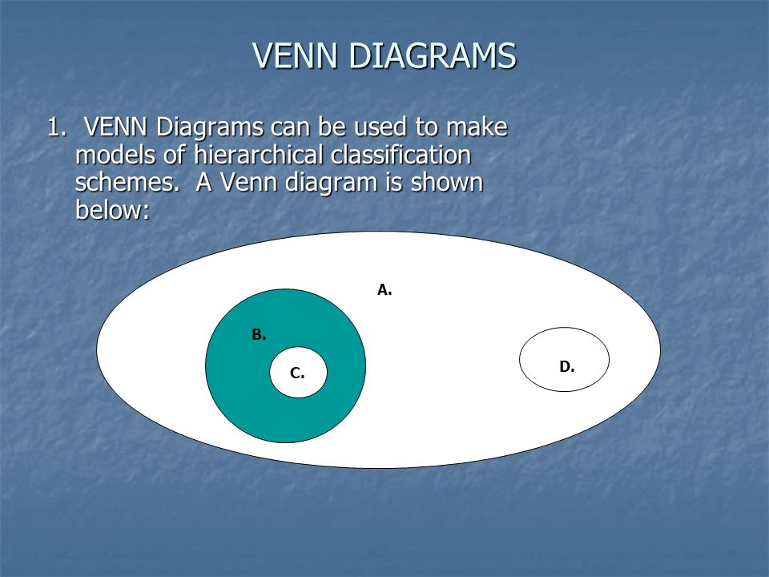

- (Classifying) Study the descriptions of the following organisms and place in the correct kingdom
  - Organism A: multicellular, photosynthetic autotrophs with cell walls that contain cellulose
  - Organism B: Cell walls lack peptidoglycan and cell membranes contain certain lipids not found in any other organisms. Many live in the most extreme environments and can survive only in the absence of oxygen
  - Organism C: Single celled, eukaryotic organisms that have chloroplasts

