STEM Biology Fall Final: Evolution and Ecology Unit guide/test questions
Answer 10; select at least 6 different types of questions. YOU MUST answer #25

1. (Formulating Hypotheses) Ecologists discovered that trout were dying in a stream that ran through some farmland where nitrogen fertilizer was used on the crops. How might you explain what happened?

2. (Using Models) Describe a food chain of which you are a member.

3. (Analyzing Data) The graph below shows the effect of annual rainfall on the rate of primary productivity in an ecosystem. What happens to productivity as rainfall increases? What factors other than water might effect primary productivity?

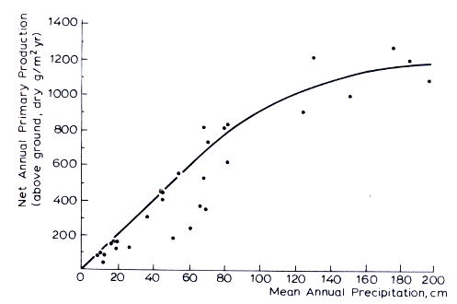

4. (Classifying) Classify each of the following as an herbivore, a carnivore, an omnivore or a detritivore: earthworm, bear, cow, snail, owl, human.

5. (Inferring) Native Americans taught European settlers to bury pieces of fish with the seeds of corn they planted. Why might this practice ensure a good harvest?

6. (Applying concepts) Although the amount of precipitation is low, most parts of the tundra biome are very wet during the summer. What characteristic would explain this apparent contradiction?

7. (Formulating Hypotheses) The deep ocean is within the aphotic zone and is also very cold. Suggest some of the unique characteristics that might enable animals to live in the deep ocean.

8. (Predicting) A windstorm in a forest blows down the large trees in one part of the forest. Soon, sun-loving plants sprout in the new clearing. What type of succession is this? What might this area look like in 5 years? In 50 years?

9. (Classifying) The cowbird lays its eggs in another birds’ nests. When the cowbird egg hatches, the “parents” feed the young cowbird along with their own young, which the cowbird then pushes out of the nest. Is this an example of mutualism, parasitism or commensalism? Explain.

10. (Inferring) Competition for resources in an area is usually more intense with a single species than between two different species. Can you explain this observation? (Hint: consider how niches help organisms of different species avoid competition.)

11. (Applying Concepts) Why might a contagious virus that causes a fatal disease be considered a density-dependent limiting factor?

12. (Inferring) Would a density-independent limiting factor have more of a effect on population size in a large ecosystem or in a small ecosystem? Explain.

13. (Predicting) Study the age structure diagram for the US below. Then predict how US’s rate of population growth is likely to change over the next 50 years.

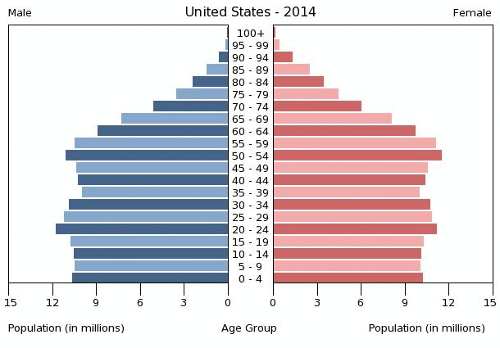

14. (Using Analogies) How is the carrying capacity of a city’s roads similar to the carrying capacity of an ecosystem?

15. (Predicting) What will happen to the population of predators if there is a sudden increase in food for the prey? Explain.

16. (Applying Concepts) If the water level of a river drops, how might that effect a fish population living in that river?

17. (Posing Questions) What questions would a demographer need to answer in order to determine whether a country is approaching the demographic transition.

18. (Predicting) Nitrogen is a limiting factor in aquatic ecosystems. Suppose that runoff from a field washes nitrogen-rich fertilizer into a pond containing a population of algae. Predict how the fertilizer will affect the carrying capacity of the pond for algae.

19. (Predicting) How might loss of biodiversity affect humans?

20. (Applying Concepts) How has suburban sprawl and the increased use of fossil fuel created problems for the biosphere?

21. (Using Tables and Graphs) Study the graph below that shows the change in global temperature from 1850 to 2000. Use the graph to answer the questions.

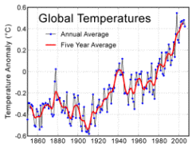

- In your own words, explain what is plotted on the y-axis. What does the unit 0.0 represent?
- How much did temperature change between 1850 and 2000?
- Describe the trend in the data between 1970 and 2000.
- Does this graph predict the pattern of global warming in the future? Why or Why not?

22. (Formulating Hypotheses) A monoculture of cotton was planted was planted in the 1980s in many southern states. A new disease invaded the cotton plants, almost completely destroying them. Explain how monoculture contributed to the effect of the disease?

23. (Calculating) The concentration of a toxic chemical is magnified 10 times at each trophic level. What will be its concentration in organisms at the fifth trophic level if producers store the substance at concentrations of 40 parts per million?

24. (Formulating Hypotheses) Different grades of coal contain different amounts of sulfur. Explain why burning low-sulfur coal can reduce acid rain.

25. (Synthesizing and applying information) What is the evolutionary and ecological importance of behavior in adapting animal populations to different and changing environments in their ecosystem? Give two examples of environmental changes that have led to behavioral adaptations that have affected evolution of a population

